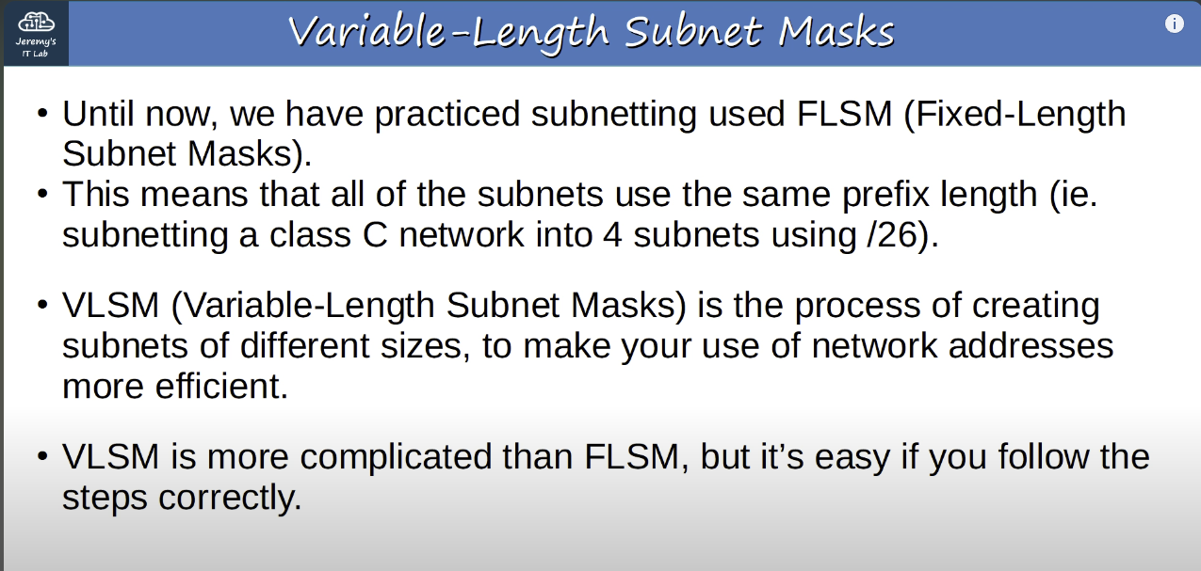
VLSM

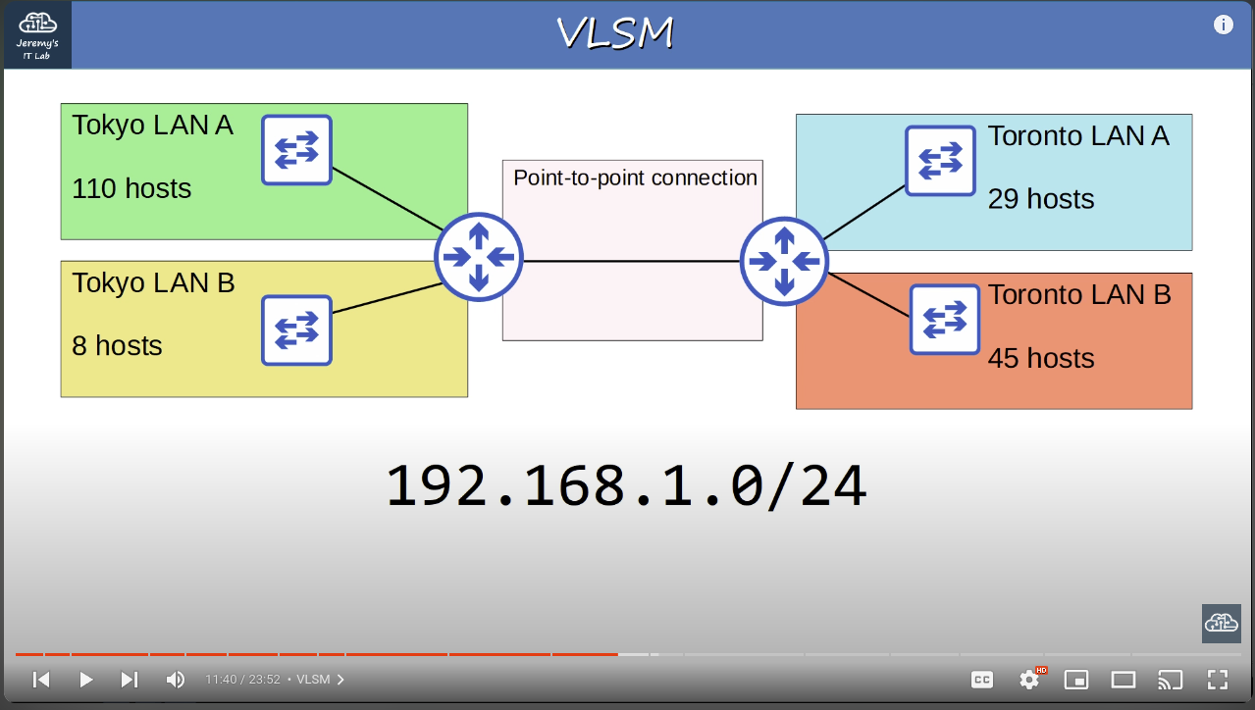
Network topology

Problem: We are assigned the 192.168.1.0/24 network,and must divide it into 5 subnets to provide IP addresses for all hosts in the enterprise network.
Note: This is network topology of some small enterprise network.
Note: Also,there is a point-to-point connection between the two routers that we must assign IP addresses for.
Note: If we were to try this with Fixed-Length Subnet Masks,we would need to borrow 3 bits to make enough subnets.That would leave 5 host bits left.5 host bits allows only 30 host addresses,so that’s not enough addresses for Tokyo LAN A or Toronto LAN B.However if we use VLSM,we can assign different subnet sizes to each LAN,which will allow us to make sure each LAN has enough addresses available.

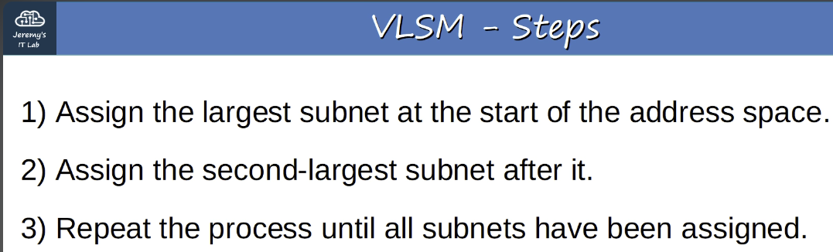
VLSM steps(for subnetting)

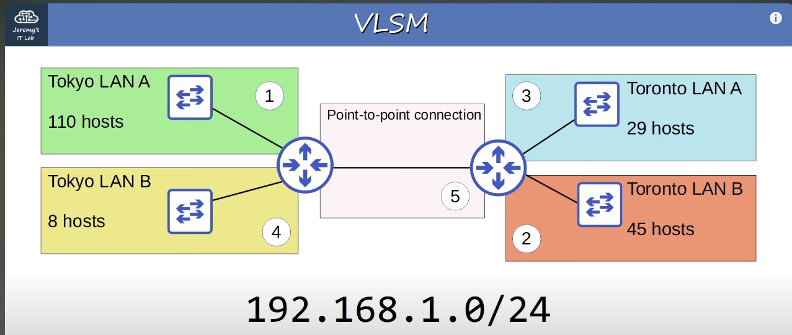
Subnet assignment order(in circles)

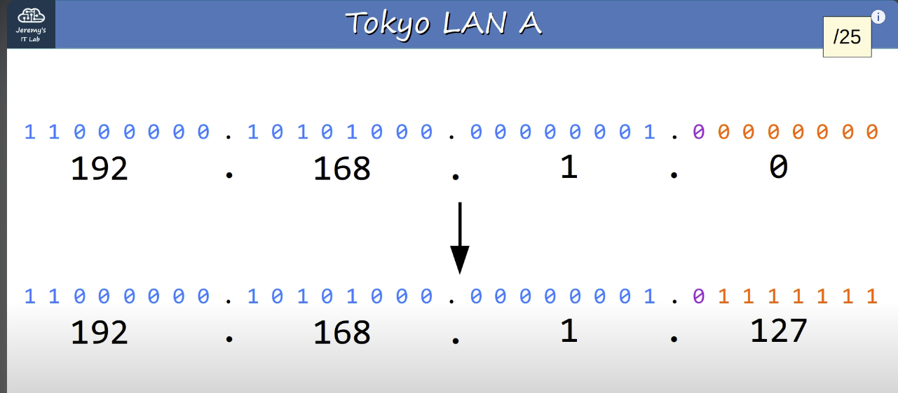
Tokyo LAN A
Note: We assign 192.168.1.0 network address to Tokyo LAN A with /25 prefix length because it is enough for 110 hosts.
Note: Second address is the broadcast address of that network.

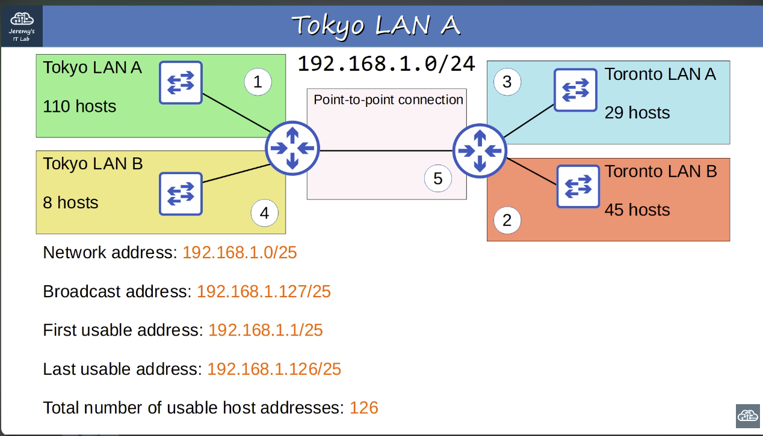
Answers for Tokyo LAN A

Note: So,next we should assign Toronto LAN B.So,192.168.1.127 is the broadcast address of Tokyo LAN A.If we add 1 to that,we will get network address of the next subnet,which will be used for Toronto LAN B.Therefore 192.168.1.128 is the network address of Toronto LAN B.But, we are missing one important point.What prefix length should we use for Toronto LAN B?

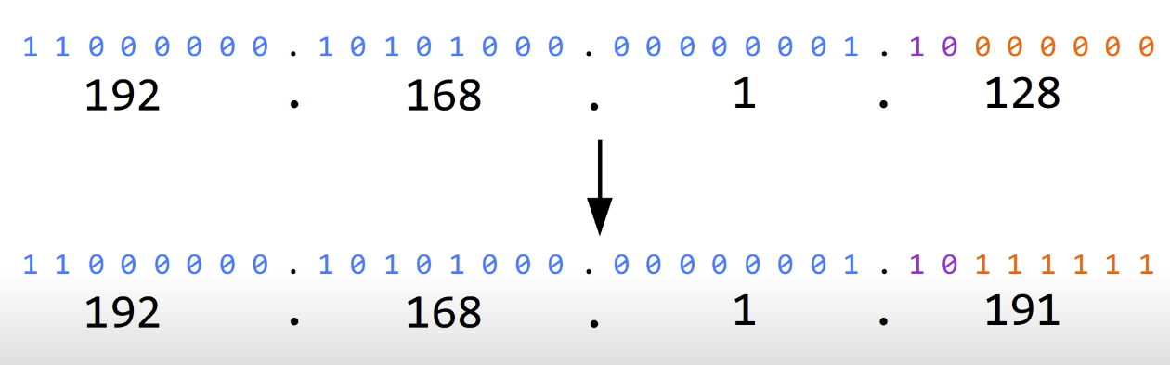
Using /26 prefix length for Toronto LAN B
Note: To accommodate the 45 hosts we will use a 26 prefix length.That leaves 6 host bits,which allows for 62 host addresses which is enough.So the complete network is 192.168.1.128/26 for Toronto LAN B.
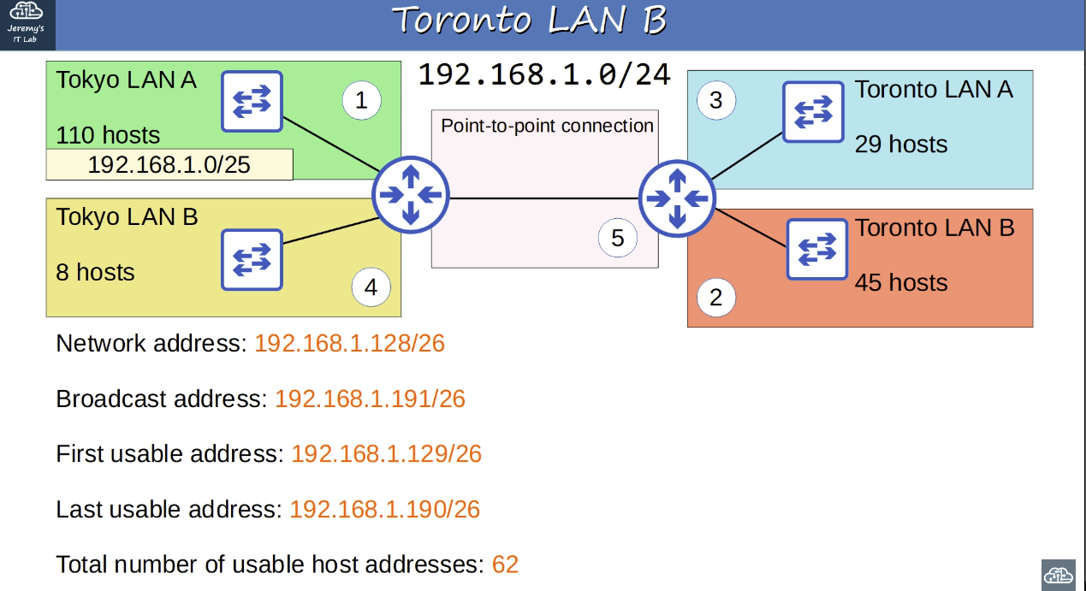
Answers for Toronto LAN B
Note: For Tokyo LAN A and Toronto LAN B,we’ve used address space from 192.168.1.0 through 192.168.1.191
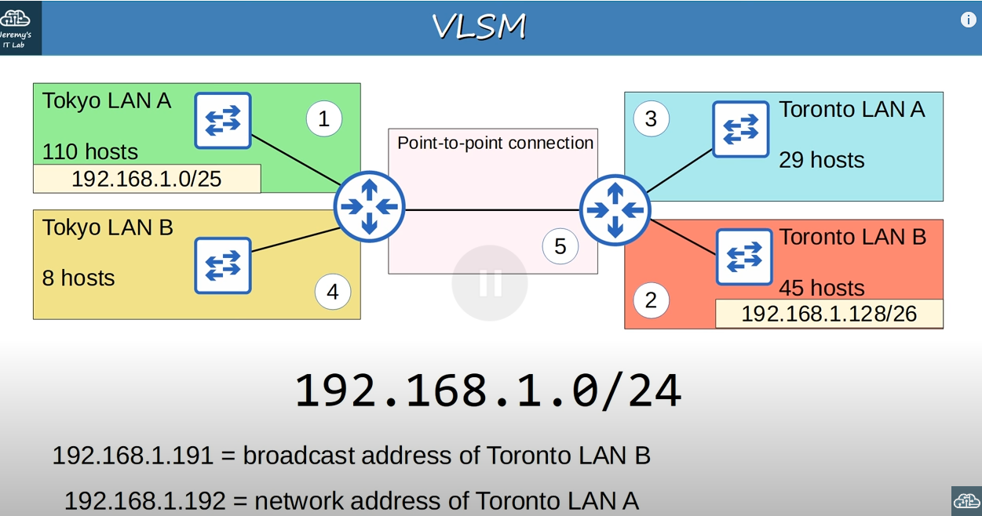
Addresses of Toronto LAN B and Toronto LAN A
Note: So next netwo in order is Toronto LAN A.Because the address of Toronto LAN B is 192.168.1.191,the address of Toronto LAN A will be 192.168.1.192
Note: We have to figure out what prefix length to use for Toronto LAN A.
Note: We find next prefix length the same way and it is /27.
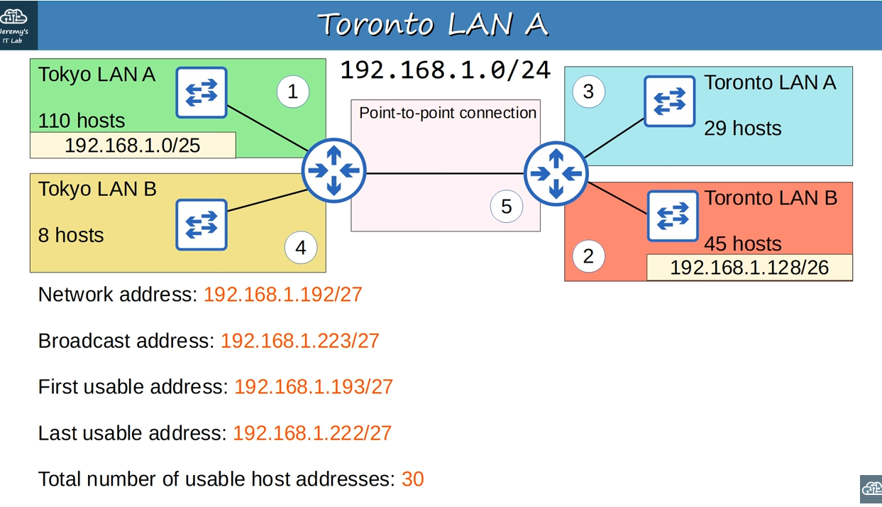
Answers for Toronto LAN A.
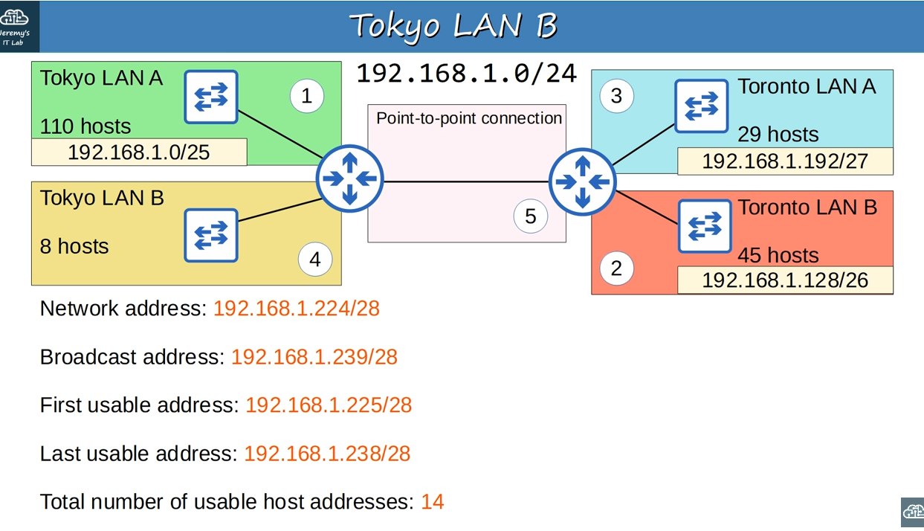
Answers for Toronto LAN B.
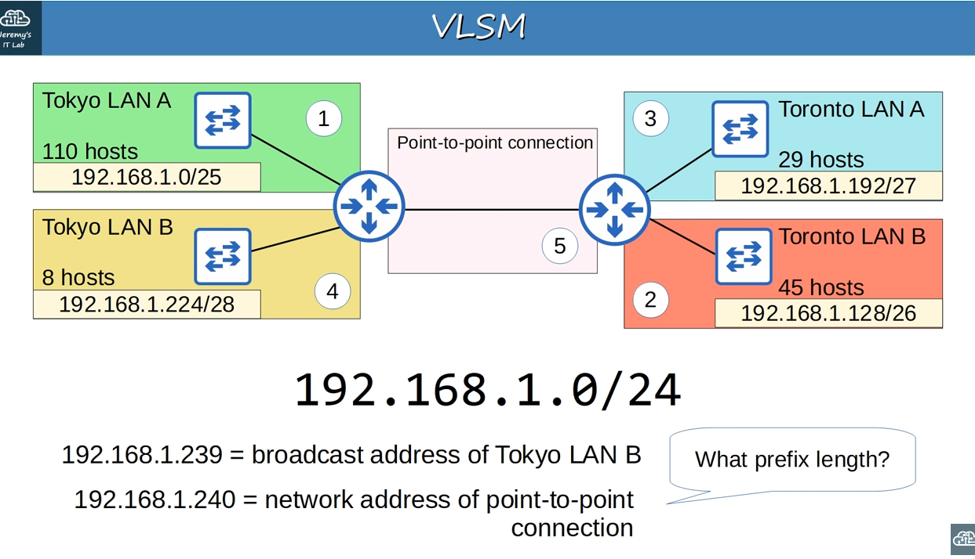
Finding out the network address of point-to-point connection
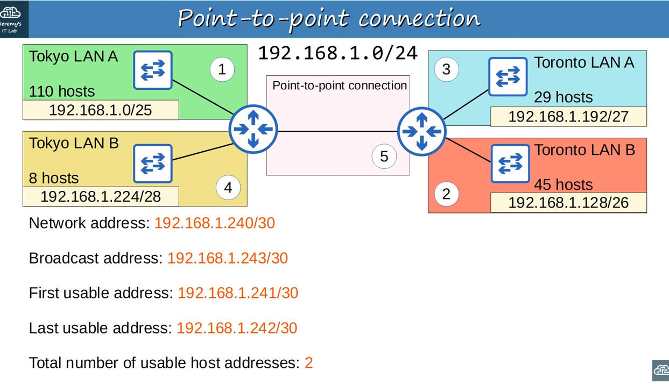
Point-to-point connection answers
Note: In point-to-point connection we could also use /31 prefix length,but for CISCO tests it is better to choose /30.

From day 15 lab
Note: If a host sends broadcast address to 255.255.255.255(no matter what network address is used in that subnet it may be 26,27/,28,the broadcast address is 255.255.255.255)
it won’t be send to be sent to all networks,it will stay in the local subnet,and a router will not route it to other networks.The subnet broadcast however,can be used by hosts in other subnets to send a broadcast to this subnet.This will be explained in next videos more detailed.

